School of Future Tech

Case Study Report

Customer Relationship Management (CRM) System

Name - Krish Shinde
Roll number - 150096725004

Index
- Introduction
- Problem Statement
- Case Study Design
- Methods and Technology Used
- Implementation Details
- Results and Conclusion
- References

Introduction
Customer Relationship Management (CRM) systems are used by businesses to store and manage customer information. They help businesses keep track of customer details and their interactions.
In this case study, a simple CRM system is developed using C++. The system allows users to add customer details, store interaction notes, and view stored records.
The purpose of this project is to demonstrate how basic programming concepts like classes, file handling, and menu-driven programs can be used to create a simple customer management system.

Problem Statement
Businesses interact with many customers every day. Without a proper system, customer details and communication history can be difficult to manage.
The objective of this case study is to create a program that allows users to:
- Add customer details
- View stored customer records
- Record interaction notes
- View interaction history
This system helps organize customer information in a simple and structured way.

Case Study Design
The CRM system is designed as a menu-driven program.
When the program starts, the user is shown a menu with the following options:
- Add Customer
- View Customers
- Add Interaction
- View Interaction History
- Exit
Customer information and interaction notes are stored in text files so that the data remains saved even after the program is closed.

Methods and Technology Used
The system uses basic programming concepts from C++.

Programming Concepts
- Classes to store customer and interaction information
- File Handling to save and read data from files
- Menu-driven logic to make the program easy to use

Technology Used
Programming Language:
C++
Libraries Used:
- iostream for input and output
- fstream for file handling
Data Storage:
- Text files (.txt)

Implementation Details
The CRM system contains two main classes.

Customer Class
This class stores customer details such as:
- Customer ID
- Customer Name
- Phone Number
It allows users to add customer data and save it in a file.

Interaction Class
This class stores interaction notes related to customers. These notes help track communication with customers.

Program Flow
- The program displays a menu.
- The user selects an option.
- The system performs the selected operation.
- Data is stored or retrieved from text files.

Snapshots
- Program menu output -
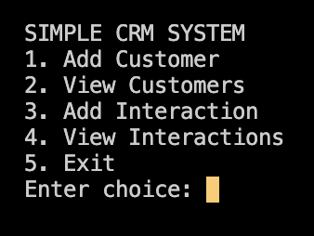
- Adding a customer-
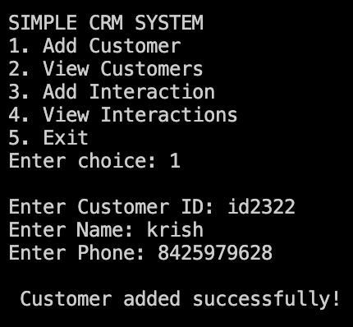
3. Viewing customer list -
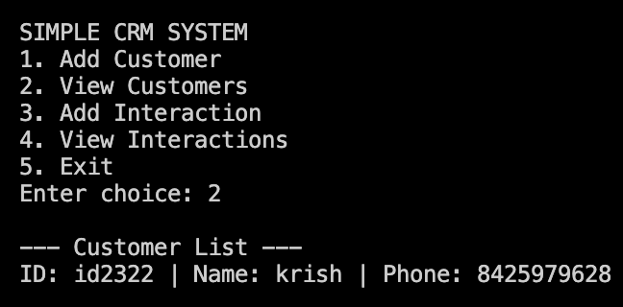
4. Adding interaction notes -
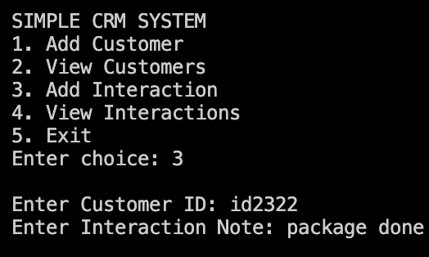

5. Viewing interaction history -
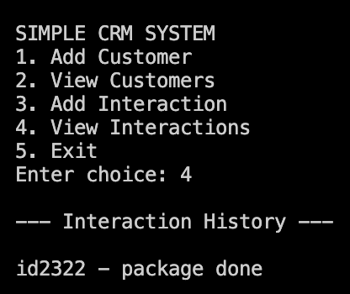

Results and Conclusion
The CRM system successfully stores customer information and interaction records. It shows how a simple program can manage data efficiently using basic programming techniques.
This case study demonstrates how object-oriented programming and file handling in C++ can be used to build a useful application.
The system can be improved in the future by adding features like a graphical user interface, database storage, and search functionality.

